GMM Assignment -2

- Implementation of Bresenham’s Line drawing algorithm. “The program should take input of the initial end-point and the final end-point, and verify whether the drawn line is smooth one or not. The program should be generic so that it works for integer values. Check for the slop of the line (i.e. m>0, m=0 and m<0)”.
- Implementation of Midpoint ellipse drawing algorithm
A). Divide the coordinate axes into four quadrants and then draw only a portion of an ellipse with the major axis as X-axis.
B). Draw another portion of the ellipse with the major axis as Y-axis to the quadrant diagonally opposite to each other. Assign different colours to them respectively. Please consider the below image as a reference:
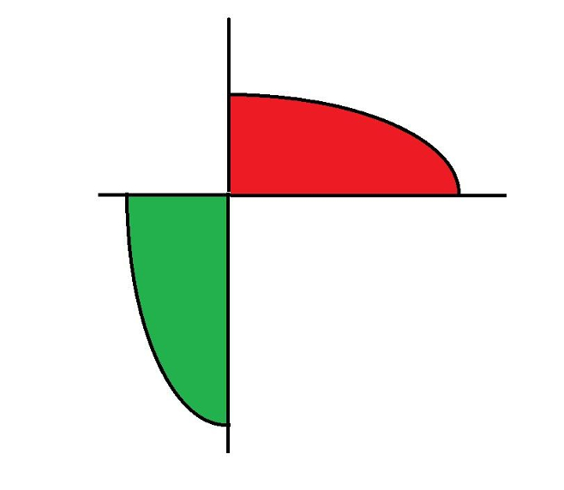
- Given the centre point coordinates (10, 10) and radius as 8, generate all the points to form a circle.
- Given the centre point coordinates (100, 100) and radius as 50, generate all the points to form a circle.

